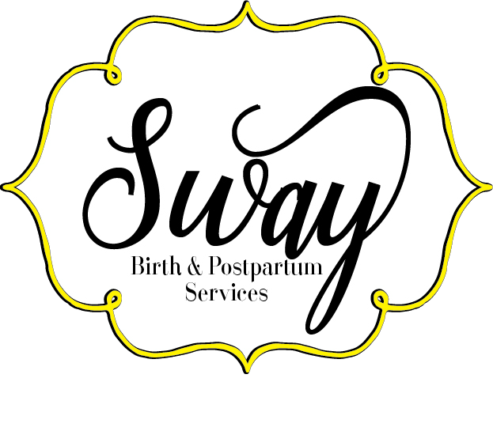

Letter of Agreement Describing Birth Doula Services, Limits and Fees

What is a doula?
As a birth doula, I accompany women in labor to help ensure a safe and satisfying birth experience. I have completed training approved by DONA International and have experience as a mother who has given birth and am gaining experience as a birth doula. I draw on my professional training, knowledge and experience to provide emotional support, physical comfort and, as needed, communication with the staff to make sure that you have the information you need to make informed decisions as they arise in labor. I can provide reassurance and perspective to you and your partner, make suggestions for labor progress, and help with relaxation, massage, positioning and other techniques for comfort. I am independent and self-employed. As your doula I am working for you, not your caregiver or hospital.

Before labor:
I will meet with you (and your partner) at least once before labor to become acquainted, to explore and discuss your priorities and any fears or concerns, to discuss your birth plan and to plan how we might best work together. I also want to know your own best ways of coping with pain and fatigue and how you and your partner foresee us working together. We may also decide on other meetings if you feel you need it. My support also includes unlimited phone and e-mail contact throughout your pregnancy.

During labor:
I prefer that you call me when you think you are in labor, even if you do not yet need me. I can answer questions and make suggestions over the phone. We will decide if I should come right then or wait for further change. I usually need approximately one hour to get to you from the time you ask me to come. We will also decide where to meet- at your home, the hospital or birth center. Except for extraordinary circumstances, I will remain with you throughout your labor and birth.

After birth:
I usually remain with you for one to two hours after birth, until you are
comfortable and your family is ready for quiet time together. I will also help with initial breastfeeding, if necessary.
I am available to answer questions about the birth or your baby and would like to get together with you within a few weeks to see how you and your baby are doing, to review the birth, and to get feedback from you about my role.

What a doula does NOT do:
- Perform clinical tasks, such as blood pressure, fetal heart checks, vaginal exams, and others. I am there to provide only physical comfort and emotional support.
- Make decisions for you. I will help you get the information necessary to make an informed decision. I will also remind you if there is a departure from your birth plan.
- Speak to the staff on your behalf. I will discuss your concerns with you and suggest options, but you or your partner will speak directly to the clinical staff.

Failure to provide service:
I will inform you of times when I am unavailable for labor support. To cover
these times, I will arrange one or more qualified back-up doulas whom you may also meet. I will make every effort to provide the services described here. Sometimes this is impossible (for example, with a rapid labor).
If my failure to provide services is due to:
- my error (such as missed call): I will refund all money minus the retainer fee.
- a fast labor: I will provide post-partum doula support to you for a maximum of 8
hours to make up for the time I was unable to be with you during labor.
- your error (failure to notify me): no fees will be refunded.
If the need for a scheduled cesarean (such as with a breech presentation) shall arise, I will provide support at the hospital and also a maximum of 8 postpartum doula hours* to you. We can plan and schedule those postpartum hours prior to scheduled surgery, after delivery or after you arrive home.
*Postpartum hours must be scheduled no less than 4 hours incriments.

Client Responsibilities:
I only ask that you keep me informed as your due date approaches. I would love
for you to call or e-mail me after appointments just to keep me up to date. I also ask that you call ASAP when labor seems to be starting so I can make the necessary arrangements.

I, as the client, give Blessed Arrivals permission for the following: (please initial)
______ To take pictures during my labor and of my baby following the birth and I understand that I may have prints of any of the pictures and that they will be used to create a special gift for me. Our first responsibility is to provide support to you. We are not professional photographers. If you desire professional birth photography you may want to consider hiring a separate photographer. We do not guarantee that we will always be able to get pictures so you may want to make sure you have your own camera as well.

______ To use a picture on the Blessed Arrivals website along with a caption that will only use first names as a birth announcement.

______ To use photos at events promoting Blessed Arrivals.

Fees for Birth Doula Services:
Our fee for the services described here is, to be paid as follows:

$150 As a retainer fee, due when you select me as your doula.

$500 ___ Due by 38 weeks.

Would you like a receipt for a Health Care Flexible Spending Account? _________
I accept Paypal (swaybirth@yahoo.com), payment plans, bartering and Checks payable to Stephanie Williams.

I/We have read this letter describing the doula's services and agree that it reflects the discussion we have had with her. By signing you also give permission for the doula to take notes about you and the course of your labor and birth.

________________________________________________________________________
Client Signature/Date

________________________________________________________________________
Birth Partner Signature

________________________________________________________________________
Doula Signature

